Title:
RoadMind: Explainable Predictive AI Co-Pilot for Advanced Driver Assistance Systems (ADAS)

Objectives:
The main objectives of Road Mind are:
- Predict potential road accidents and hazardous situations using machine learning.
- Analyze important factors such as speed, acceleration, weather, road conditions, traffic, and driver behavior.
- Provide early warnings before a potentially dangerous situation occurs.
- Use Explainable AI (XAI) to explain why the system generated a particular prediction.
- Reduce the risk of accidents by supporting better driver decision-making.
- Develop a system that can be integrated with future ADAS and autonomous driving systems.
- Classify driving situations into different risk levels such as Low, Medium, and High Risk.

Flow Chart of the Project
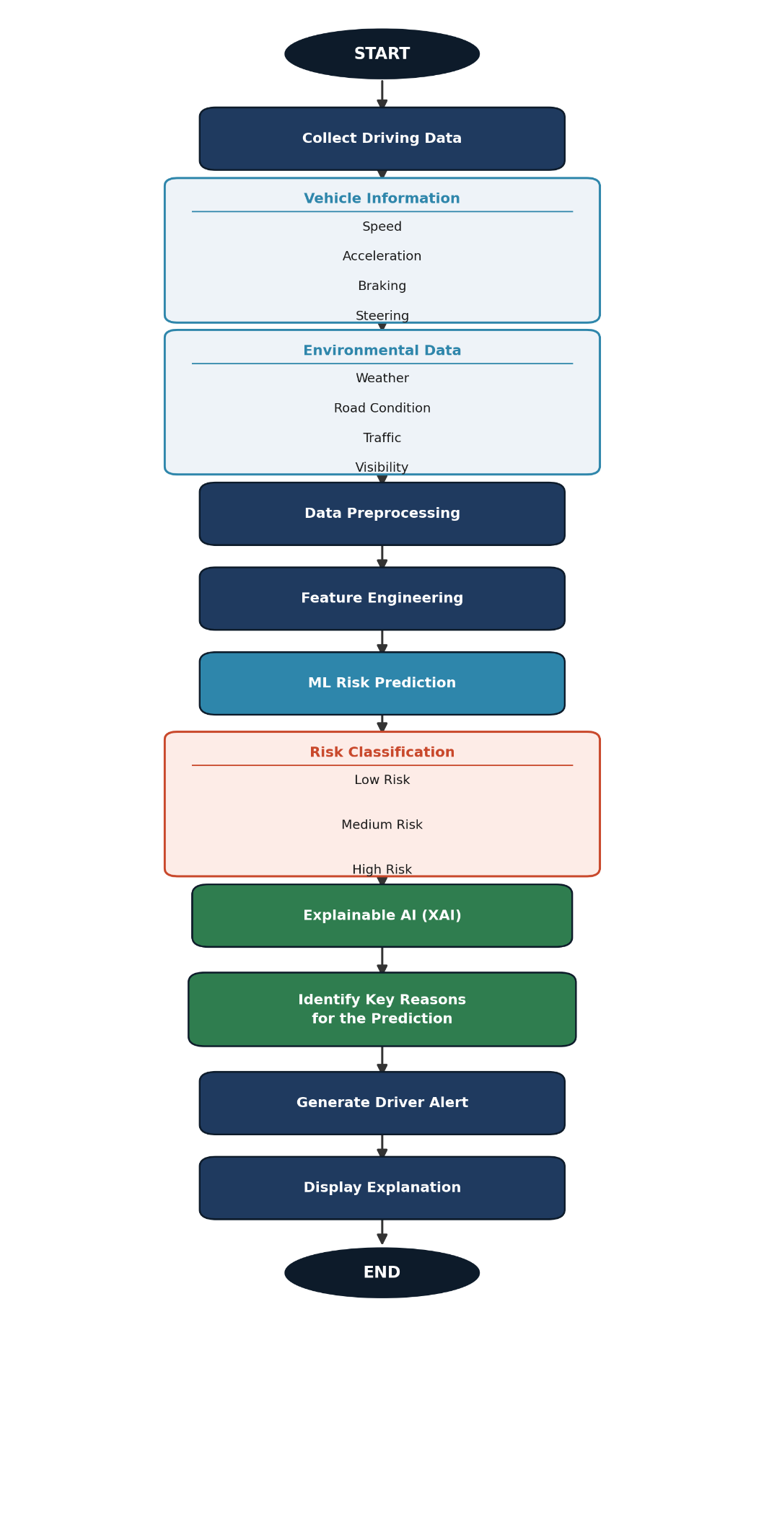
Methodology Overview:

The proposed system follows a 6-stage methodology:
DATASET
↓
DATA PREPROCESSING
↓
FEATURE ENGINEERING
↓
ML MODEL TRAINING
↓
RISK PREDICTION
↓
EXPLAINABLE AI (XAI)
↓
DRIVER WARNING

1. Data Collection
We collect road accident and driving-condition data from publicly available datasets such as the US Accidents Dataset.
The dataset contains information such as:
- Weather condition
- Visibility
- Temperature
- Wind speed
- Road conditions
- Traffic signals
- Junctions
- Time and location
- Accident severity

2. Data Preprocessing
The collected dataset is cleaned before giving it to the machine-learning model.
Steps:
- Remove duplicate records
- Handle missing values
- Remove unnecessary columns
- Convert categorical data into numerical values
- Normalize/scale numerical features when required

3. Feature Engineering
Important features that can influence accident risk are selected from the dataset.
For example:
Input:
Weather + Visibility + Traffic + Road Condition + Time + Temperature
↓
Risk-related features

The processed data is divided into:
- Training data
- Testing data
Machine-learning algorithms such as Random Forest or XGBoost are trained to predict the level of road risk.
For example:
Input Conditions
↓
ML Model
↓
Risk Probability
↓
Low / Medium / High Risk

5. Risk Prediction
When new driving conditions are provided, RoadMind predicts the risk level.
Example:
Speed → High
Visibility → Low
Weather → Rain
Traffic → Heavy
Road → Wet
↓
HIGH RISK
The system can provide a probability such as:
Risk Probability = 87%

6. Explainable AI (XAI)
This is the key feature of RoadMind. Instead of only giving a prediction, the system explains why the prediction was made.
We can use SHAP (Shapley Additive explanations) to identify the most influential features.
HIGH RISK – 87%
Example:
Main Reasons:
1. Poor visibility █████████
2. Wet road ████████
3. Heavy traffic ███████
4. High speed ██████
5. Rainy weather █████

